Range Partiton:EID 1to 10
11 to 20
List Partition:Location based
Hash partion for junk data:you can do 0 to 9 partition for this
Key partition:on any index or key like (primary) key
Range Partition Example
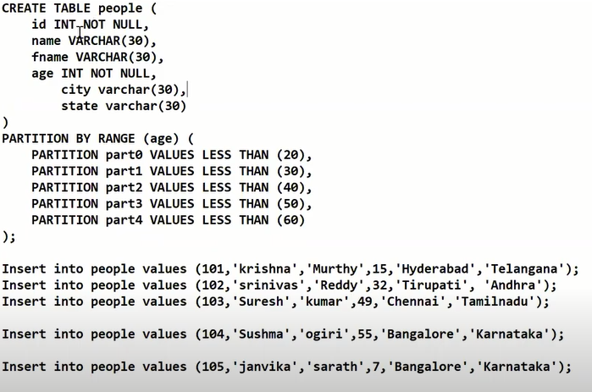

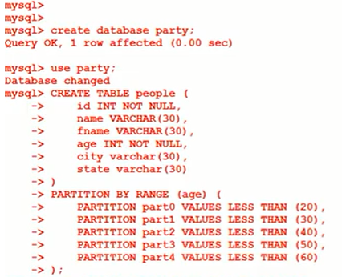
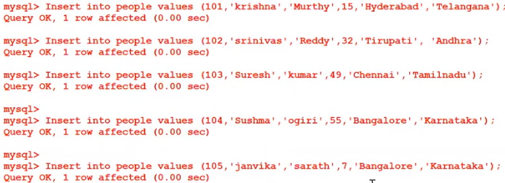
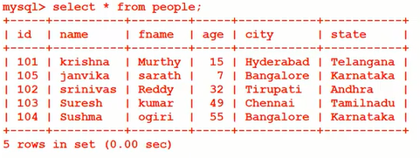
Here age 7 will be store in partition 0
Now do this
It will showing error because we don’t have that partition
To solve error
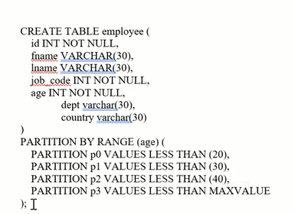
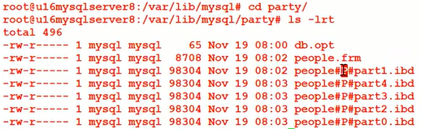

List Partition
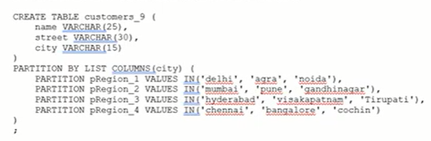
Hash Partition
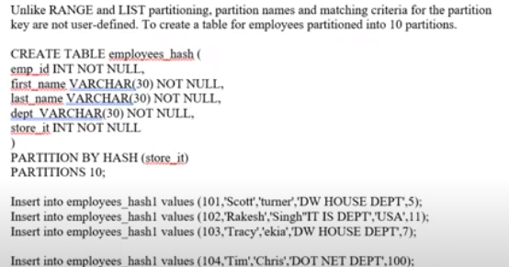
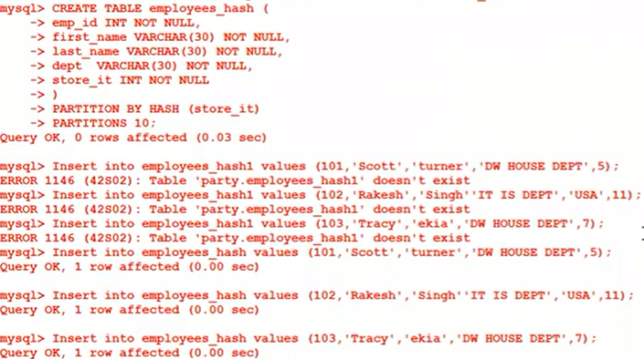

Data will be split in 10 partition
Key Partition
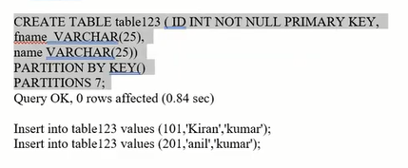
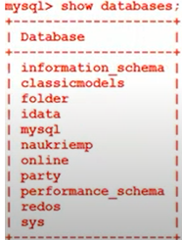
https://youtu.be/3m9X0-9sCU0

